Frames
Assignment 4
Create a nested frame as given below.
When user clicks on the first link the file should open in frame 2 and when the user clicks on the second link the file should open in the 3rd frame.

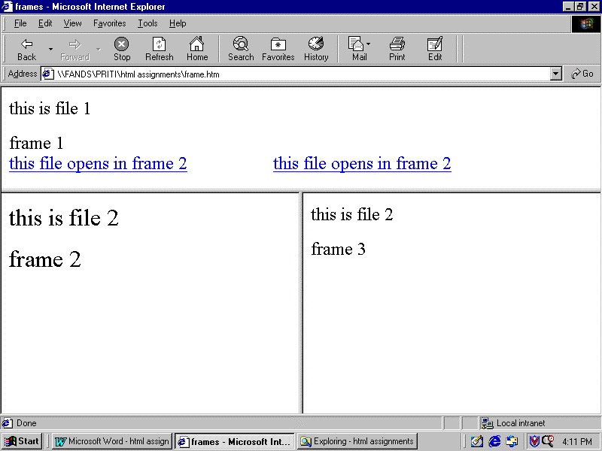

Assignment 5
Create two frames where in the first frame we have a list of all the files created by you as links to the file. When user clicks on the links the file should open in the second frame.
When the page is loaded the second frame should have information about you. In this file use background color fonts lists etc to present the information.
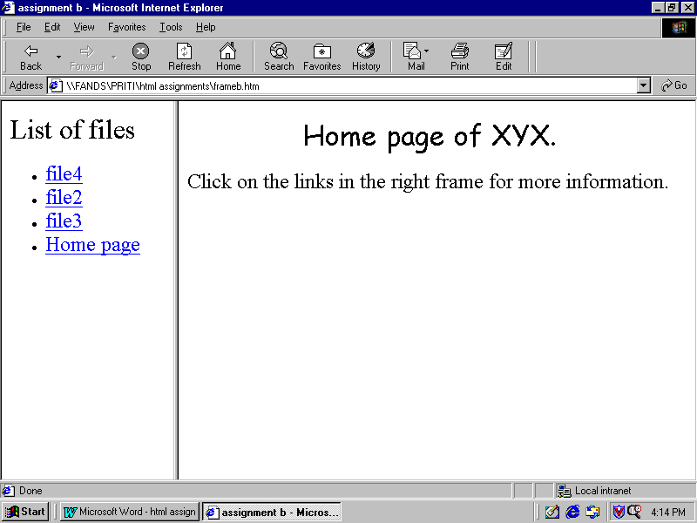
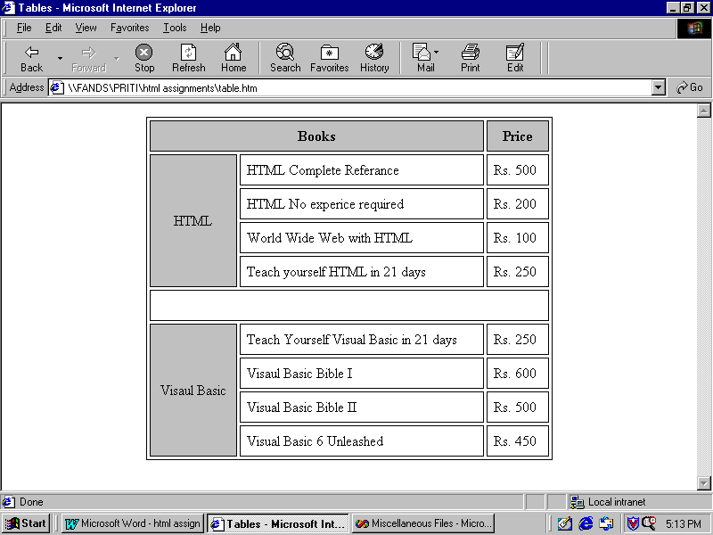
Tables
Assignment 6

Assignment 7 Nested tables
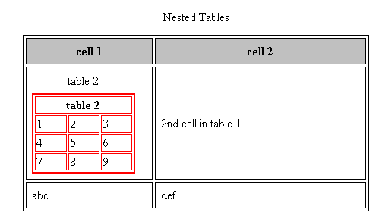
Forms
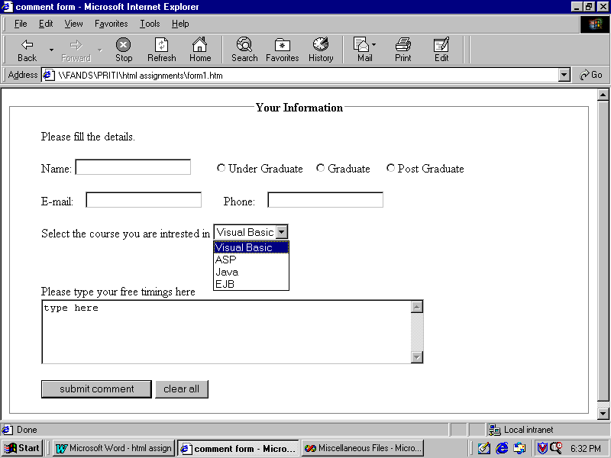
Assignment 8

In the above form the user should be able to select any one of the raidio buttons only.

Assignment 9
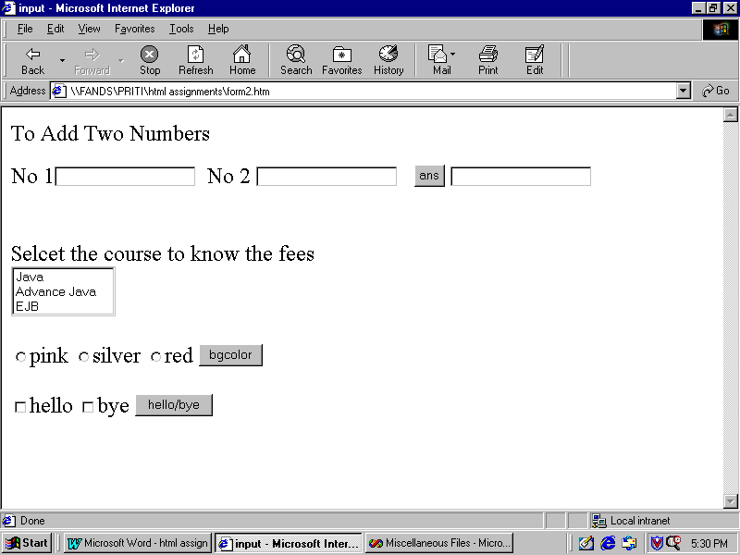

Create a form as above
- User should enter two numbers in the text boxes and on clicking on the ans button the result of the addition of these two numbers should be displayed.
- When user selects any course from the list a message box should be displayed showing the fees for the course.
- Depending on which radio button the user selects on clicking the bgcolor button the background color of the document should change.
- Depending on which check box the user selects on clicking the hello/bye button message box should be displayed with the relevant message. And if both check boxes are checked the message should be accordingly.

Assignment 10 (using divisions and DHTML)
- Create a list of courses this list should be displayed when the user clicks on the title.
- Create a page with some images on moving the mouse over that image the image should change.

Assignment 11

Style sheet
Create an external style sheet with the following rules.
- Create class a with the following rules
  - Text color is white
  - Font family is arial size is 20pt
  - Background is black
- For the P tag give the following rule
  - Background is silver
  - Alignment is right
  - Font size 20pt
- For H1.B
  - Text Color green
  - Font size 30pt
  - Background color red

Create a HTML document as follows and apply the above external stylesheet to the P and H1 tags. Also give inline style to the paragraph where the rule is as follows
- Text alignment is center
- Background color is yellow

PART II ASSIGNMENTS

